**PacMan**



* **Local**: D:\dev\JavaScript\10_pacman\pacman.html
  + **Repo**: JavaScript
    - **Branch**: Master
      * **Commit**: Added first row of blocks



* **Local**: D:\dev\JavaScript\10_pacman\pacman.html
  + **Repo**: JavaScript
    - **Branch**: Master
      * **Commit**: Added five rows

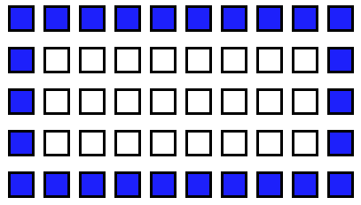

* **Local**: D:\dev\JavaScript\10_pacman\pacman.html
  + **Repo**: JavaScript
    - **Branch**: Master
      * **Commit**: Added color to the boundary block
* **Local**: D:\dev\JavaScript\10_pacman\pacman.html
  + **Repo**: JavaScript
    - **Branch**: Master
      * **Commit**: …
* **Local**: D:\dev\JavaScript\10_pacman\pacman.html
  + **Repo**: JavaScript
    - **Branch**: Master
      * **Commit**: …
* **Local**: D:\dev\JavaScript\10_pacman\pacman.html
  + **Repo**: JavaScript
    - **Branch**: Master
      * **Commit**: …
* **Local**: D:\dev\JavaScript\10_pacman\pacman.html
  + **Repo**: JavaScript
    - **Branch**: Master
      * **Commit**: …
* **Local**: D:\dev\JavaScript\10_pacman\pacman.html
  + **Repo**: JavaScript
    - **Branch**: Master
      * **Commit**: …